LOGO

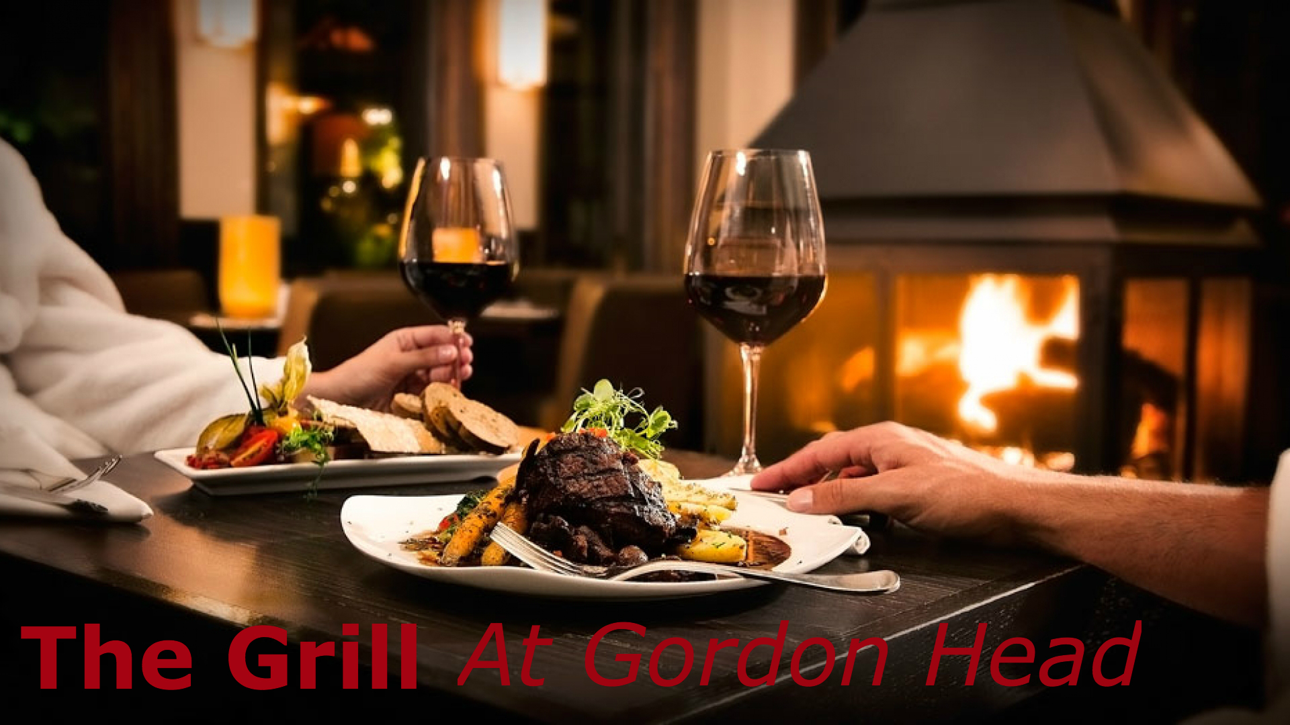

OPEN SIGN
Open Hours

DINING ROOM
Sunday - Thursday 4:30pm - 10pm
Friday - Saturday 4:30pm - 11pm

BAR
Monday - Thursday 4:30pm - 11pm
Friday - Saturday 4:30pm - Midnight
Sunday 4:30pm - 10pm

BUSINESS CARD

Colin Gall (CEO)
E-Mail: Colin.gall123@gmail.com
Phone: 250-885-5642
Fax: 250-477-1969
The Grill at Gordon Head
1690 Kenmore Road Victoria, BC V8N2E5
Web: TheGrillGH.com

