Catagory | Recommended Product | Why? | Price
Chair | Ergohuman ME7ERG-W09-01W09-01  Black Mesh Hi-Swivel Chair  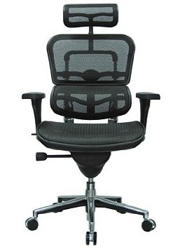 | It is currently the best desk chair on the market and the design of the chair is made to fit your body like a glove. It is currently the highest rated chair for conformability and ergonomics. | Retail is $1,248.00 however, it is currently on sale on amazon for $629.00, 50% off.
Desk | Walker Edison Soreno 3-Piece Corner Desk  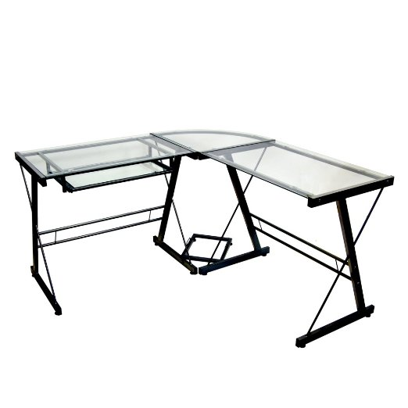 | Since this desk is a corner desk you can put anything you need on it. It could hold all your items like you monitor or monitors, printer, phone, and anything else while looking very clean and sleek. | Retail is $249.00 however it is on sale on Amazon for $96.00, 39% off.
Computer | Cyber Power Black Pearl Computer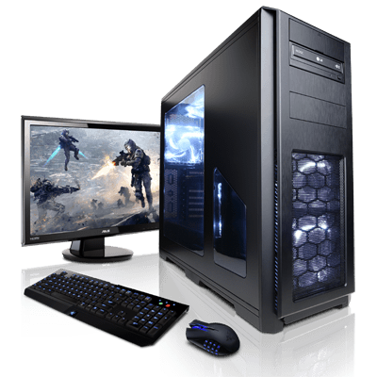 | This computer comes as a set with an HD monitor and high quality gaming mouse. All of this features the same colour way as the other items I would place in my office. It is a high quality computer made specifically for computer games so I would never need to sacrifice power. Also, if I was ever done work I could play computer games on it. | The set with the monitor, computer, and mouse costs $1595 before tax and shipping.
Speakers | Bose Companion 5 Multimedia 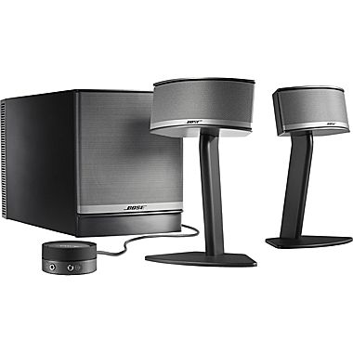 | These speakers feature a high quality of audio and also share the same modern look as the rest of the items in my office space. | They retail at $400.

